

ASSIGNMENT TOP SHEET
Faculty of Creative Arts, Technologies & Science
Department of Computer Science and Technology

Student Ref. No: 1946732 | Unit Code  CIS017-1

Unit Name  Computer Systems Structure |  | Deadline for Submission(s)

Student Name:

Unit Team
Sue Brandreth

Assignment Details:

Assignment 1 – Design and Implement a Database

Instructions to Students:

Please note:
Work presented in an assessment must be your own. Plagiarism is where a student copies work from another source, published or unpublished (including the work of another student) and fails to acknowledge the influence of another’s work or to attribute quotes to the author. Plagiarism is an academic offence and the penalty can be serious. The University’s policies relating to Plagiarism can be found in the regulations at http://www.luton.ac.uk/livingandstudying/qa/documents. To detect possible plagiarism we may submit your work to the national plagiarism detection facility. This searches the Internet and an extensive database of reference material including other students’ work. Once your work has been submitted to the detection service it will be stored electronically in a database and compared against work submitted from this and other universities. It will therefore be necessary to take electronic copies of your materials for transmission, storage and comparison purposes and for the operational back-up process. This material will be stored in this manner indefinitely.

I have read the above information and I confirm that this work is my own and that it may be processed and stored in the manner described.

Signature (Print Name): ARIYANA NAGASSAR.................................. Date: ...27/11/20.................................

Extension deadline
Mitigation Team agrees that the assignment may be submitted ____ days after the deadline and should be marked without penalty.

Mitigation Team confirmation.................................................................................................................

All assignments must be electronically submitted using Turnitin (via BREO) by 10am on the due date. Please leave sufficient time to meet this deadline and do not leave the handing-in of assignments to the last minute. You need to allow time for any system problems or other issues.
Table of Contents

- Introduction 3
  - Assumptions
- Tasks:
  - Entity Relationship Model 4
  - Normalization 5
  - Physical Table Design
(including Data Dictionary) 6-9
  - Query Design 10-14
  - Implementation of the Database 15-26
- Discussion and reflection 27 - 28

Introduction

A hotel would like to provide an online service for customers to book rooms and to check their upcoming trips.
A database needs to be created to store customer data (name, address, email, telephone number) and booking information (start and end date, double or single room) as well as room information, indicating whether a room is a single or double room.
Each booking must be assigned to exactly one single or double room as indicated in the booking.
Customers who are not registered yet need to register (providing their address, phone number, email address and credit card information).
A registered customer should be able to book a room, i.e., provide the check-in and check-out date and if a double or single room is required, via a graphical user interface.
Customers should also be able to view their bookings and change or cancel them if needed.
All these operations are only possible after a customer signs in (which means they must be registered).
Your system should also check if the requested room (single or double room) is available for the time of stay.
After a booking is made, hotel managers must assign an appropriate room to each booking, matching the customer’s demand regarding single or double room.
To determine whether a room is available during the requested time period, the hotel manager should be able to see existing bookings per room.
Hotel managers must also sign in before any operation can be performed.

Assumptions

The following assumptions were observed and identified upon analysis of the Case Study:

- A potential customer who has not yet registered would be considered a browser and they may be able to look at pages which provide information on the room types with images and descriptions of their features, amenities included, view and décor.
- There are forty rooms inside with each floor containing five rooms each.
- A customer can register but not make a booking until a later period.
- A customer can make more than one booking at a time such as for future accommodation or book several rooms at the same time for co-workers, friends and family etc.
- A customer can upon registration enter one credit card and change these details or add another card details in the future.
- Credit card information will be verified upon log in and it is possible some registered users may enter invalid information.
- The hotel will aim to have approximately at least 95% through the year with the ability to allow customers to make emergency bookings.
- Room rates may vary due to high or low season, according the amenities provided in the room and the room view.
- The hotel may provide a cot at additional request and may have rooms where a couch can be converted to a bed if needed.
- A customer can have the option to make a special request such as a morning wake up call, a reminder their check out time is approaching or provide items such as an iron if available.
- Bookings are not confirmed until a room is assigned by the Hotel Manager so the customer will be notified of this confirmation via email or an alert on their account.
- Booking confirmations would be done quickly upon request to ensure customer satisfaction.
- The hotel will provide WIFI and therefore Customers will not need to request this service.

Task A:
Entity Relationship Model (ERM)

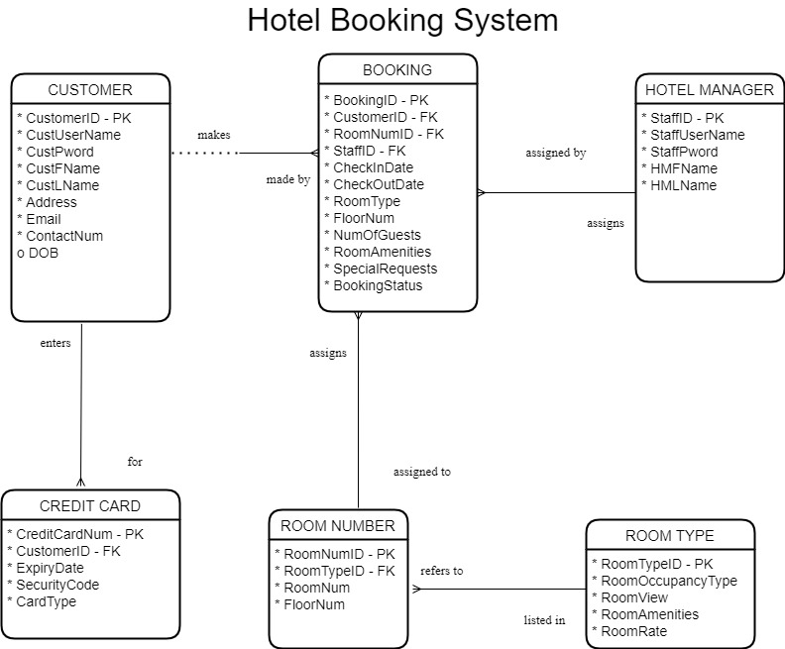

Figure 1: Entity Relationship Model diagram – Hotel Booking System

Entities | Relationships
CUSTOMER/BOOKING | Each Customer may make one or more Bookings. | Each Booking must be made by one Customer.
CUSTOMER/CREDIT CARD | Each Customer may enter one or more Credit Card. | A Credit Card must be entered by a Customer.
BOOKING/HOTEL MANAGER | Each Booking must be assigned a room by Hotel Manager. | Each Hotel Manager must assign a room to one or more Bookings.
ROOM NUMBER/ROOM TYPE | Each Room Number must be assigned a Room Type. | A Room Type must be assigned to one or more Room Number.
BOOKING/ROOM NUMBER | Each Booking must be assigned a Room Number | A Room Number may be assigned one or more Bookings

Table 1: Relationship notation between Entities on ERD Diagram using Oracle Notation.

Task B:
Normalization

UNF | 1NF | 2NF | 3NF
CustomerID  CustomerUserName  CustPword  CustFName  CustLName  Address  Email  ContactNum  DOB  CreditCardNum  ExpiryDate  SecurityCode  CardType  BookingID  CheckInDate  CheckOutDate  RoomType  FloorNum  NumOfGuests  RoomAmenities  SpecialRequests  BookingStatus  RoomTypeID  RoomOccupancyType  RoomView  RoomAmenities  RoomRate  RoomNumID  RoomNum  FloorNum  StaffID  StaffUserName  StaffPword  StaffFName  StaffLName | CustomerID  CustomerUserName  CustPword  CustFName  CustLName  Address  Email  ContactNum  DOB  CreditCardNum  ExpiryDate  SecurityCode  CardType  CustomerID*  BookingID  CheckInDate  CheckOutDate  RoomType  FloorNum  NumOfGuests  RoomAmenities  SpecialRequests  BookingStatus  RoomTypeID  RoomOccupancyType  RoomView  RoomAmenities  RoomRate  RoomNumID  RoomNum  FloorNum  StaffID  StaffUserName  StaffPword  StaffFName  StaffLName CustomerID* | CustomerID  CustUserName  CustPword  CustFName  CustLname  Address  Email  ContactNum  DOB  CreditCardNum  ExpiryDate  SecurityCode  CardType  CustomerID*  BookingID  CheckInDate  CheckOutDate  RoomType  FloorNum  NumOfGuests  RoomAmenities  SpecialRequests  BookingStatus  StaffUserName  StaffPword  StaffFName  StaffLName  RoomTypeID  RoomOccupancyType  RoomView  RoomAmenities  RoomRate  RoomNumID  RoomNum  FloorNum  CustomerID* | CustomerID  CustomerUserName  CustPword  CustFName  CustLName  Address  Email  ContactNum  DOB  CreditCardNum  ExpiryDate  SecurityCode  CardType  CustomerID*  BookingID  CheckInDate  CheckOutDate  RoomType  FloorNum  NumOfGuests  RoomAmenities  SpecialRequests  BookingStatus  CustomerID*  RoomNumID*  StaffID*  RoomTypeID  RoomOccupancyType  RoomView  RoomAmenities  RoomRate  RoomNumID  RoomNum  FloorNum  RoomTypeID*  StaffID  StaffUserName  StaffPword  StaffFName  StaffLName

Table 2: Normalization Form using data extracted from the created Entity Relationship Diagram

Task C:
Physical Table Design (including Data Dictionary)

Part A: Skeleton Tables

- Customer (Customer ID, Cust UserName, Customer Pword, Cust FName, Cust LName, Address, Email, Contact Num, DOB)
- Credit Card (Credit Card Num ID, Customer ID*, Expiry Date, Security Code, Card Type)
- Booking (Booking ID, Customer ID*, Room Num ID*, Staff ID*, Check In Date, Check Out Date, Room Type, Floor Num, Num of Guests, Special Requests, Booking Status)
- Hotel Manager (Staff ID, Staff UserName, Staff Pword, Staff FName, Staff LName)
- Room Type (Room Type ID, Room Occupancy Type, Room View, Room Amenities, Room Rate)
- Room Number (Room Num ID, Room Type ID*, Room Num, Floor Num)

Part B: Data Dictionary

Table: Customer
Description: Customer details
Field Name | Datatype | Length | Index | Null | Default | Validation rule | Description
Customer_ID  (Primary) | integer | 15 | PK | No |  |  | Auto-incremented to uniquely identifies every registered customer
Cust_UserName | varchar(20) | 20 |  | No |  |  | Customer created User Name to Log In. A version of their first and last name.
Cust_Pword | varchar(15) | 15 |  | No |  | Must contain a Capital letter and Special character | Customer password
Cust_FName | varchar(20) | 20 |  | No |  |  | First Name of the customer
Cust_LName | varchar(20) | 20 |  | No |  |  | Last Name of the customer
Address | varchar(40) | 40 |  | No |  |  | Email of customer
Email | varchar(30) | 30 |  | No |  | Must contain an @ and a ‘.’ | Customer email and unique to each customer
Contact_Num | Numeric(20) | 20 |  | No |  |  | Customer contact number and unique to each customer
DOB | DATE |  |  | No |  |  | Customer Date of Birth

Indexes
Keyname | Type | Unique | Column | Null
PRIMARY | BTREE | Yes | Customer_ID | No

Table 3: Data Dictionary for Customer Entity’s attributes used for creation of Database Table

Table: Credit Card
Description: Credit Card details
Field Name | Datatype | Length | Index | Null | Default | Validation rule | Description
CreditCardNum  (Primary) | integer | 25 | PK | No |  |  | Customer credit card number and should be unique to every customer
Customer_ID | integer | 15 | FK | No |  |  | The ID number of the Customer who created the Booking.
Expiry_Date | numeric(4) | 4 |  | No |  |  | Expiry Date on credit card
Security_Code | numeric(6) | 6 |  | No |  |  | Security Code on credit card
Card_Type | varchar(10) | 10 |  | No |  |  | Type of credit card e.g Visa, MasterCard etc.

Indexes
Keyname | Type | Unique | Column | Null
PRIMARY | BTREE | Yes | CreditCardNum | No

Table 4: Data Dictionary for Credit Card Entity’s attributes used for creation of Database Table

Table: Hotel Manager
Description: Hotel Manager details
Field Name | Datatype | Length | Index | Null | Default | Validation rule | Description
Staff_ID  (Primary) | integer | 15 | PK | No |  |  | Auto-incremented to uniquely identifies every staff member.
Staff_UserName | varchar(20) | 20 |  | No |  |  | User Name given to Staff to Log In. A version of their first and last name.
Staff_Pword | varchar(15) | 15 |  | No |  | Must contain a Capital letter and Special character  Expires every 60 days. | Staff password.
Staff_FName | varchar(20) | 20 |  | No |  |  | First Name of the Hotel Manager
Staff_LName | varchar(20) | 20 |  | No |  |  | First Name of the Hotel Manager

Indexes
Keyname | Type | Unique | Column | Null
PRIMARY | BTREE | Yes | Booking_ID | No

Table 5: Data Dictionary for Hotel Manager Entity’s attributes used for creation of Database Table

Table: Room Type
Description: Room Type Details
Field Name | Datatype | Length | Index | Null | Default | Validation rule | Description
Room_TypeID  (Primary) | varchar(10) | 10 | PK | No |  |  | uniquely identifies the room type and amenities included.
Room_OccupancyType | varchar(25) | 25 |  | No |  | Single, Double Room | The type of room
Room_View | varchar(15) | 15 |  | No |  | East, West, North, South | Type of view the Room offers
Room_Amenities | varchar(25) | 25 |  |  |  |  | Room amenities such as Basic or Extra w/o Balcony etc.
Room_Rate | decimal(10) | 10 |  | No |  |  | Room Rate
Indexes
Keyname | Type | Unique | Column | Null
PRIMARY | BTREE | Yes | Room_TypeID | No

Table 6: Data Dictionary for Room Type Entity’s attributes used for creation of Database Table

Table: Room Number
Description: Room Number Details
Field Name | Datatype | Length | Index | Null | Default | Validation rule | Description
Room_NumID  (Primary) | integer | 15 | PK | No |  |  | Auto-incremented to uniquely identifies the room number
Room_TypeID | integer | 15 | FK | No |  |  | The type of room
Room_Num | INT |  |  | No |  |  | Room Number
Floor_Num | INT |  |  | No |  |  | The floor the room is on.

Indexes
Keyname | Type | Unique | Column | Null
PRIMARY | BTREE | Yes | Room_NumID | No

Table 7: Data Dictionary for Room Number Entity’s attributes used for creation of Database Table

Table: Booking
Description: Booking details
Field Name | Datatype | Length | Index | Null | Default |  | Validation rule | Description
Booking_ID  (Primary) | integer | 15 | PK | No |  |  |  | Auto-incremented to uniquely identifies every processed booking.
Customer_ID | integer | 15 | FK | No |  |  |  | The ID number of the Customer who created the Booking.
Room_NumID | integer | 15 | FK | No |  |  |  | The Room Num ID assigned to the Booking
Staff_ID | integer | 15 | FK | No |  |  |  | The Staff ID of the Hotel Manager who approved and assigns the Booking.
Check_InDate | DATE | 20 |  | No |  |  | Cannot be a past date | Check In Date starts the Booking period.
Check_OutDate | DATE | 20 |  | No |  |  | Must be after check in date | Check Out Date ends the Booking period.
Room_Type | varchar(20) | 20 |  | No |  |  |  | Whether they would like a Single or Double
Floor_Num | INT |  |  | No |  |  |  | The Floor number on which a customer may prefer to stay on.
Room_Amenities | varchar(40) | 40 |  | No |  |  |  | Customers can choose amenities which reflect rates eg Basic and Extra, Balcony/No Balcony
Num_OfGuests | INT |  |  | No |  |  |  | Number of Guests checking in on the Booking.
Special_Requests | varchar(40) | 40 |  | No |  |  |  | Special Requests made by Customers for the duration of their stay.
Booking_Status | varchar(20) | 20 |  | No |  |  |  | Shows the status of the Booking e.g. Processing, Cancelled, Confirmed etc.

Indexes
Keyname | Type | Unique | Column | Null
PRIMARY | BTREE | Yes | Booking_ID | No

Table 8: Data Dictionary for Booking Entity’s attributes used for creation of Database Table

Task D:
Query Design

Query One
A subquery Update statement was tested as a way for management to set to give the booking a Room Number, set the Staff ID and confirm/reject the Booking and reflect this via the Booking Status.

UPDATE Booking
SET Room_NumID = 'DE27', Staff_ID = '2', Booking_Status = 'Confirmed'
WHERE Booking_ID = 1;

UPDATE Booking
SET Booking_Status = 'Rejected'
WHERE Booking_ID = 5;

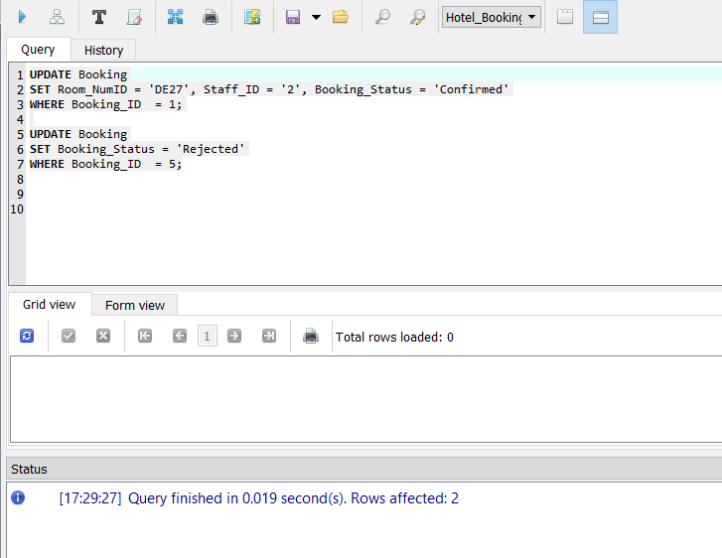
Figure 2: Update Query Statement successfully implemented

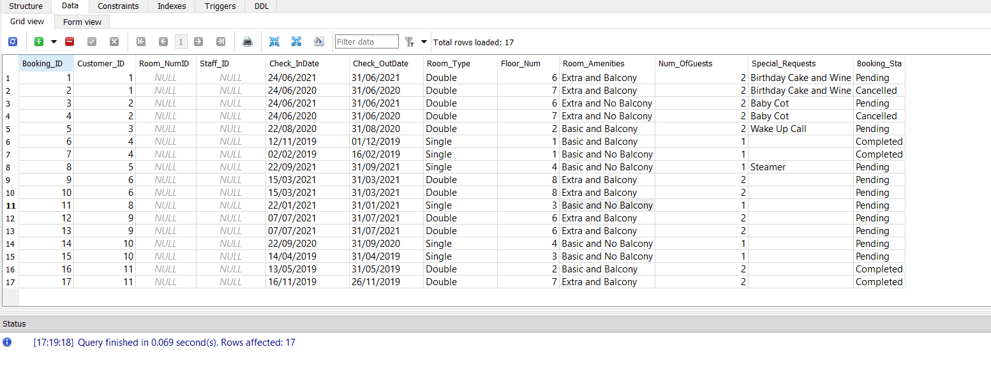
Figure 3: Booking Table before query was run
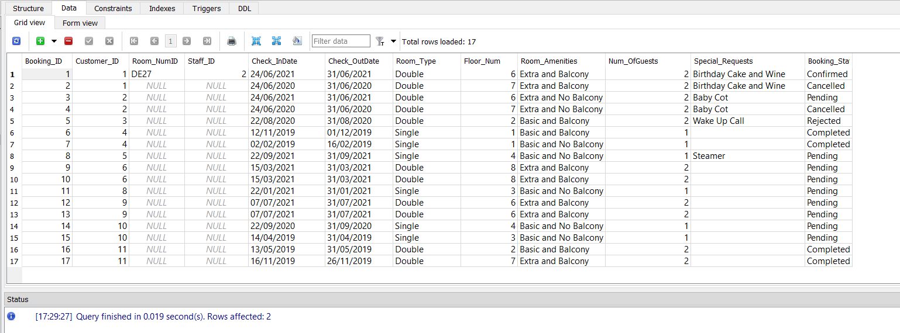
Figure 4: Booking Table after query was finished with changes made to BookingID and 5

Query Two

The second query designed and tested was a Join Query. This was used to join Customer and Booking Status which can be used to how many bookings have been created registered customer and would also indicate if a registered customer has not yet created a booking.

SELECT Customer_ID, Cust_FName, Cust_LName, Booking_ID, Booking_Status
FROM Customer AS C
LEFT JOIN Booking AS o
on c.customer_id = o.customer_id

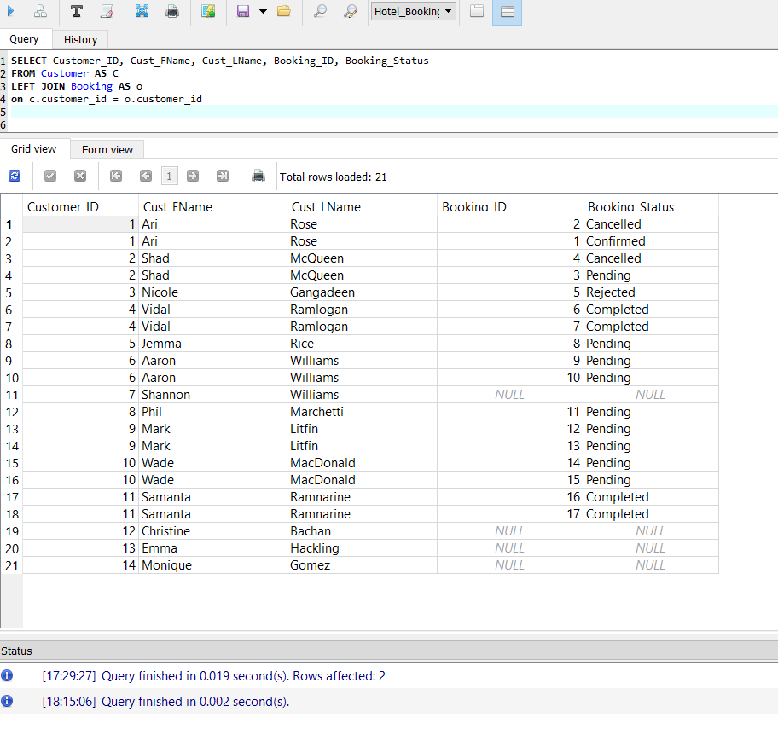
Figure 5: Showing the results of the Left Join Query with null values for some customers

Query Three

The third query designed was using the join query to merge Customer, Bookings and Credit Card information. Staff can use this to flag those with upcoming reservations with expiring cards to update their records.

SELECT a.Customer_ID, a.Cust_FName, a.Cust_LName,
b.Check_InDate, b.Check_OutDate, b.Room_Type, b.Room_Amenities, b.Booking_Status, c.CreditCard_Num, c.Expiry_Date
FROM Customer a
INNER JOIN Booking b
ON a.customer_id = b.customer_id
INNER JOIN CreditCard c
ON a.customer_id =c.customer_id
WHERE b.Booking_Status = 'Pending'

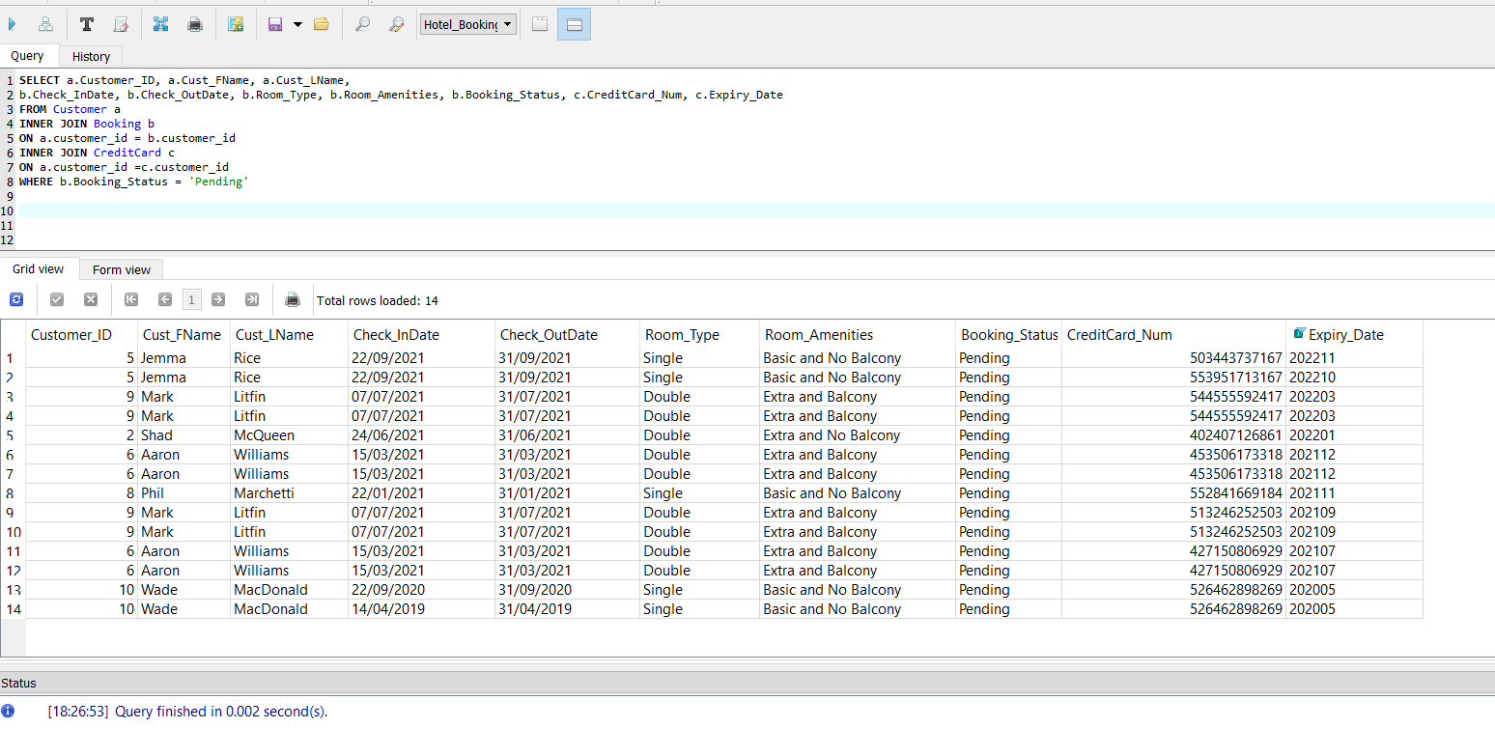
Figure 6: Showing successful run of Inner Join query with three tables.

Query Four

The forth query designed was a Select query to review the Booking Status against the Check In and Check Out Date for each Customer. Can be used to check if Bookings are properly closed off by staff when the customer checks out.

SELECT
Booking_ID ,Booking_Status, Check_InDate, Check_OutDate, Room_Type , customer.customer_ID
FROM Booking, Customer
WHERE
Booking.Customer_ID = Customer.Customer_ID
AND
Booking_Status = 'Completed'

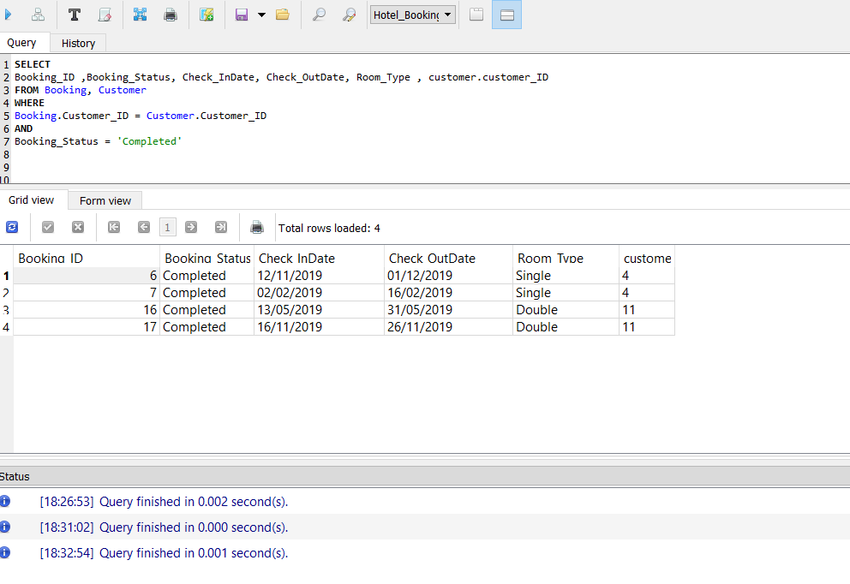
Figure 7: Successfully Select query showing completed bookings

Query Five

The fifth query created was to a Distinct query to eliminate all duplicate records which can occur if a customer signs up multiple times using the same name.

SELECT DISTINCT Cust_FName, Cust_LName, Address FROM Customer;

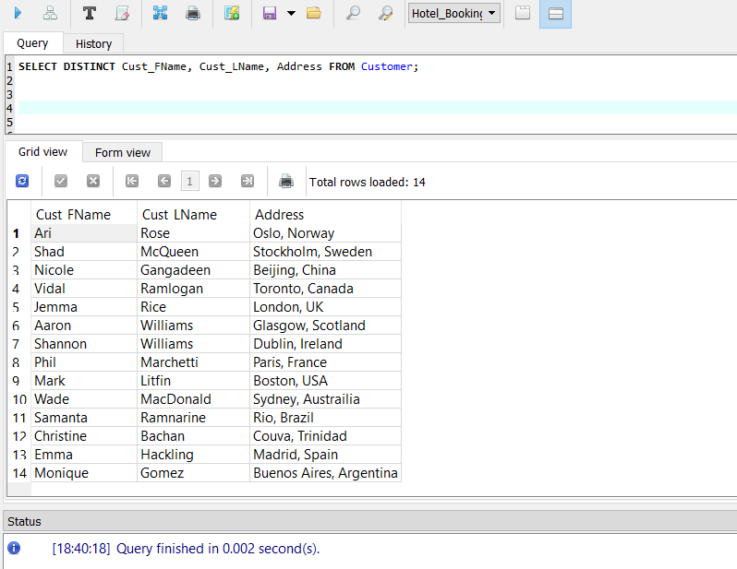
Figure 8: Completed query showing the distinct users.

Query Six

The sixth query created was a Count query to verify how many credit card numbers are stored by customers. Some customers may store multiple in the event they have multiple bookings and are paying for this via multiple payments

SELECT Customer_ID, COUNT(CreditCard_Num)
FROM CreditCard
GROUP BY Customer_ID
HAVING COUNT(Customer_ID)
ORDER BY COUNT(Customer_ID) DESC;

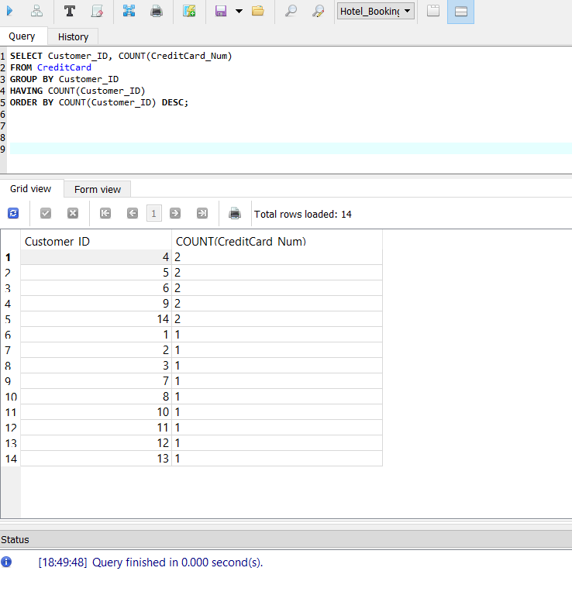
Figure 9: Completed query showing the Count users.

Task E:
Implementation of the Database
Task E.1 – Create Tables

Create Customer Table
CREATE TABLE Customer (
Customer_ID INTEGER PRIMARY KEY AUTOINCREMENT UNIQUE NOT NULL,
Cust_UserName varchar (20) UNIQUE,
Cust_Pword varchar (15),
Cust_FName varchar (20),
Cust_LName varchar (20),
Address varchar (40),
Email varchar (30) UNIQUE,
Contact_Num numeric (20) UNIQUE,
DOB DATE
)
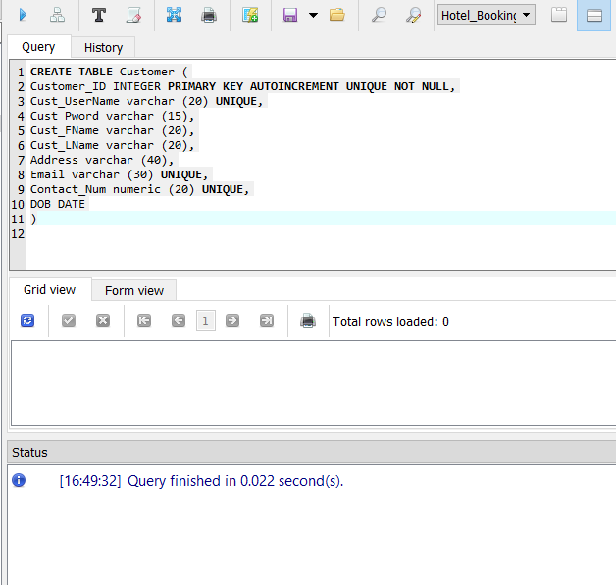
Figure 10: Created Table Statement passed.
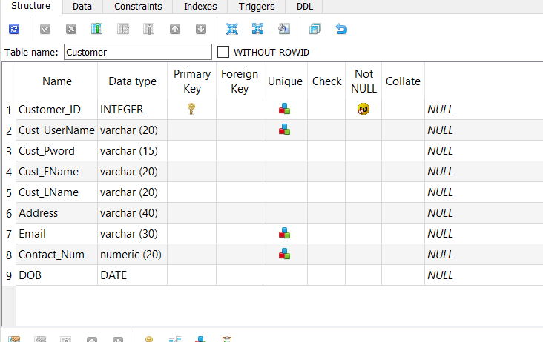
Figure11: Created Customer Table
Create Credit Card Table
CREATE TABLE CreditCard (
CreditCard_Num INTEGER PRIMARY KEY UNIQUE NOT NULL,
Customer_ID INTEGER REFERENCES Customer (Customer_ID),
Expiry_Date varchar (4),
Security_Code varchar (6),
Card_Type varchar (10)
)
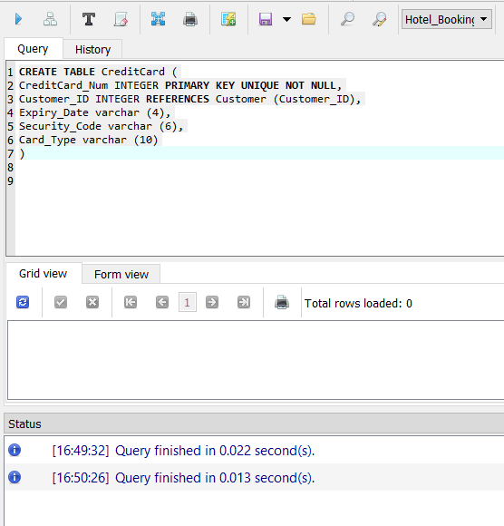
Figure12: Create Credit Card Statement

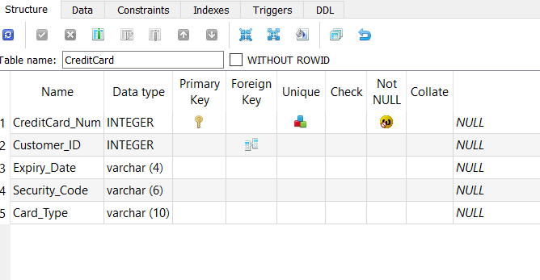
Figure 13: Created Credit Card Table

Create Hotel Manager
CREATE TABLE HotelManager (
Staff_ID INTEGER PRIMARY KEY AUTOINCREMENT UNIQUE NOT NULL,
Staff_UserName varchar (20) UNIQUE,
Staff_Pword varchar (15),
Staff_FName varchar (20),
Staff_LName varchar (20)
)

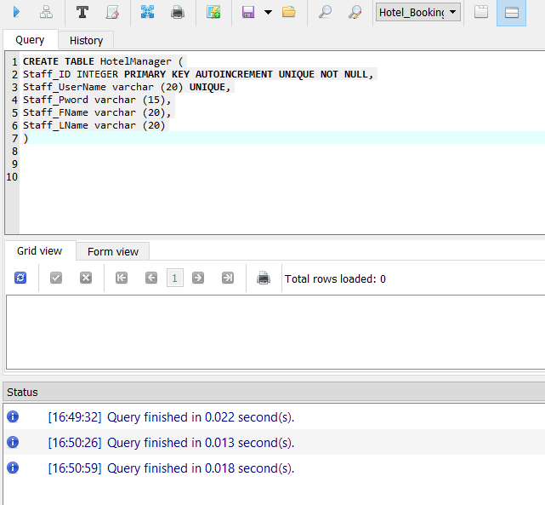
Figure 14: Create Hotel Manager Statements.

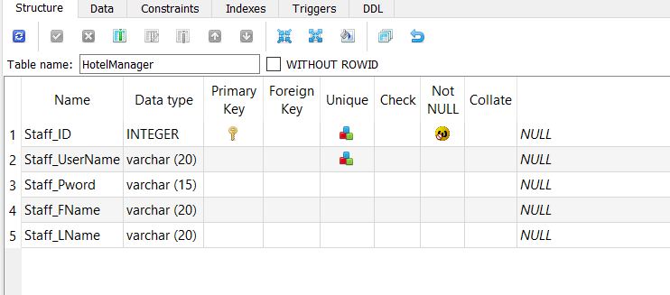

Figure 15: Created Hotel Manager Table

Create RoomType Table
CREATE TABLE RoomType (
Room_TypeID INTEGER PRIMARY KEY UNIQUE NOT NULL,
Room_OccupancyType varchar (25),
Room_View varchar (15),
Room_Amenities varchar (25),
Room_Rate decimal (10)
)

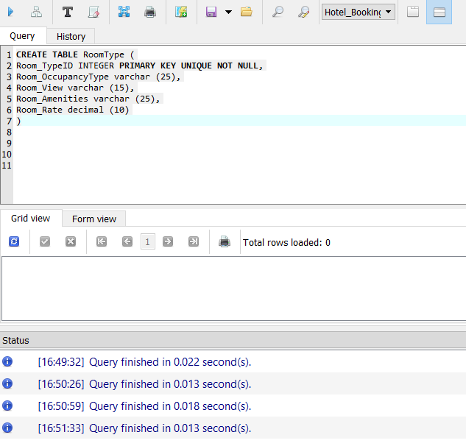
Figure 16: Create RoomType Statements.

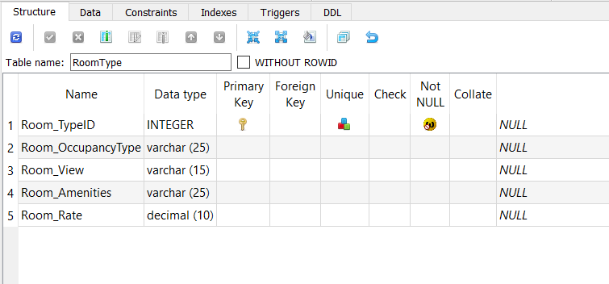

Figure 17: Created RoomType Table

Create Room Number Table
CREATE TABLE RoomNumber (
Room_NumID varchar(15) PRIMARY KEY NOT NULL,
Room_TypeID INTEGER REFERENCES RoomType (Room_TypeID),
Room_Num INT,
Floor_Num INT
)

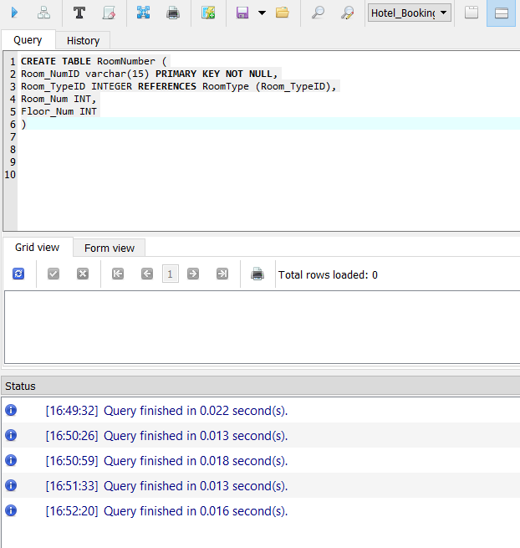
Figure 18: Create Room Number Statement

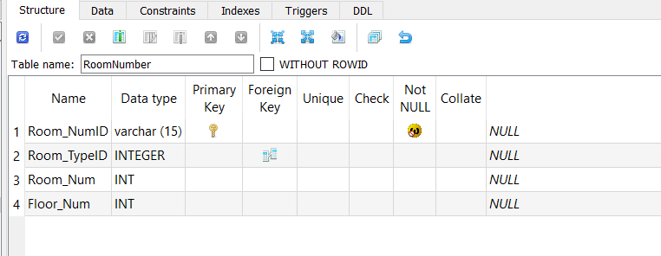

Figure 19: Created RoomNumber Table

Create Booking Table
CREATE TABLE Booking (
Booking_ID INTEGER PRIMARY KEY AUTOINCREMENT UNIQUE NOT NULL,
Customer_ID INTEGER REFERENCES Customer (Customer_ID),
Room_NumID INTEGER REFERENCES RoomNumber (Room_NumID),
Staff_ID INTEGER REFERENCES HotelManager (Staff_ID),
Check_InDate DATE,
Check_OutDate DATE,
Room_Type varchar(20),
Floor_Num INT,
Room_Amenities varchar(40),
Num_OfGuests numeric (5),
Special_Requests varchar(40),
Booking_Status varchar(20)
)

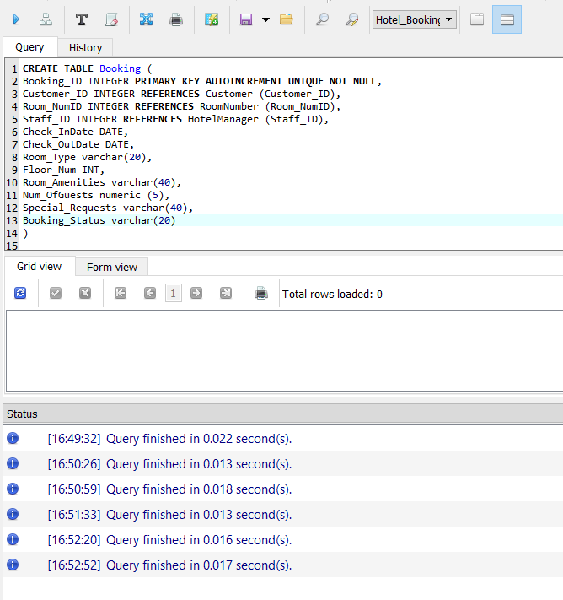
Figure 20: Create Booking Statement

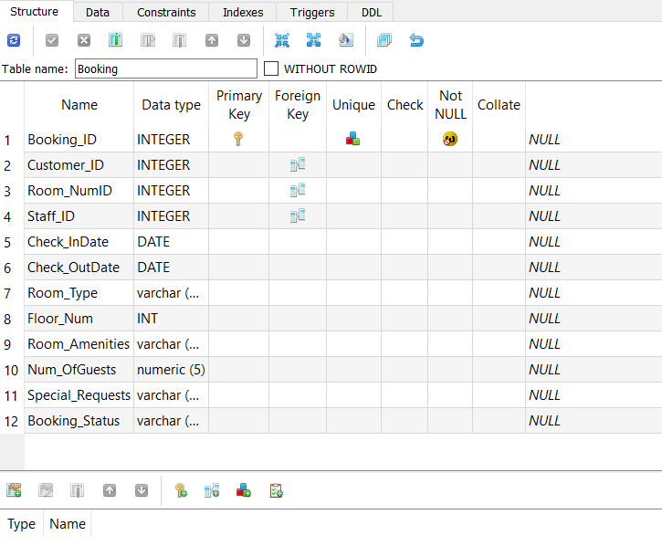
Figure 21: Created Booking Table

Task E.2 – Insert Data into Tables.
Insert Data into Customer

INSERT INTO Customer (Cust_UserName, Cust_Pword, Cust_FName, Cust_LName, Address, Email, Contact_Num, DOB)
VALUES ('A.Rose', 'ManUtd12', 'Ari', 'Rose', 'Oslo, Norway','darkangel1263@hotmail.com', '2678123', '26051991' );
INSERT INTO Customer (Cust_UserName, Cust_Pword, Cust_FName, Cust_LName, Address, Email, Contact_Num, DOB)
VALUES ('S.McQueen', 'Plants12', 'Shad', 'McQueen', 'Stockholm, Sweden','shadkb@hotmail.com', '7085733', '07021990' );

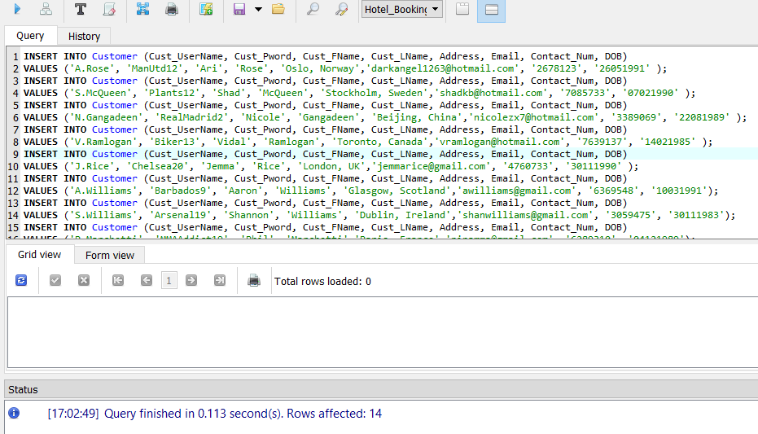
Figure 22: Customer Insert Statement table
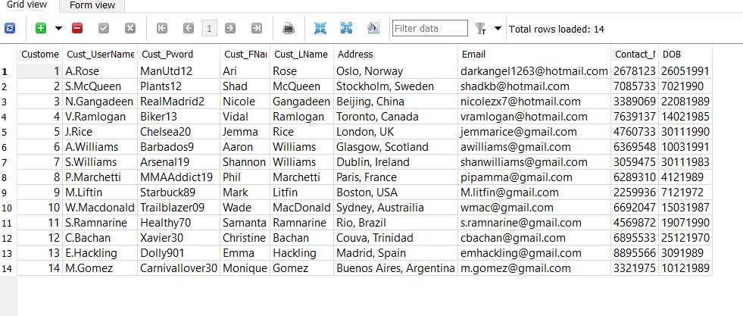
Figure 23: Customer Data.

Credit Card Insert Data

INSERT INTO CreditCard (CreditCard_Num, Customer_ID, Expiry_Date, Security_Code, Card_Type)
VALUES (' 471679471097', '1', '202210', '306', 'Visa');
INSERT INTO CreditCard (CreditCard_Num, Customer_ID, Expiry_Date, Security_Code, Card_Type)
VALUES ('402407126861 ', '2', '202201', '310', 'Visa');
INSERT INTO CreditCard (CreditCard_Num, Customer_ID, Expiry_Date, Security_Code, Card_Type)

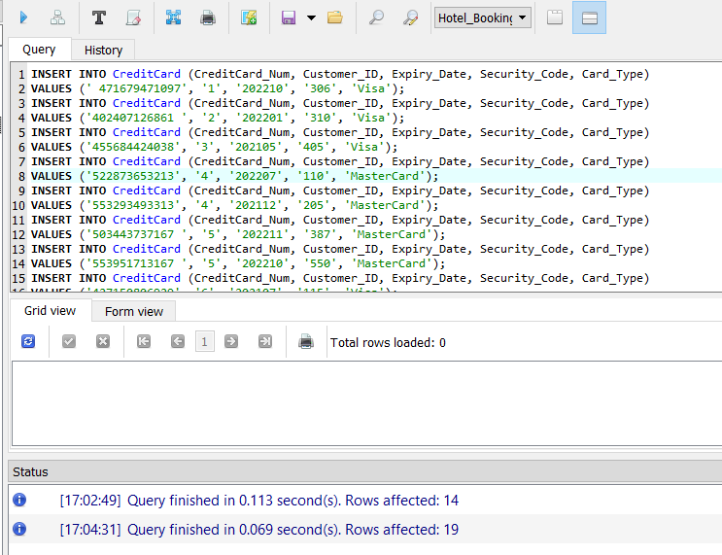
Figure 24: Insert Credit Card statement.

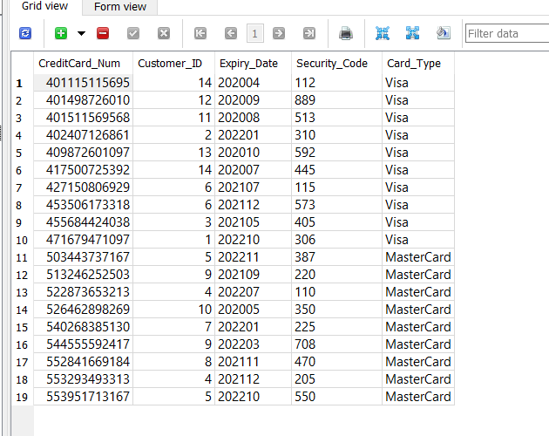
Figure 25: Inserted data in Credit Card table

Insert Data – Hotel Manager

INSERT INTO HotelManager (Staff_UserName, Staff_Pword, Staff_FName, Staff_FName)
VALUES ('L.Praimdass', 'GymAddict1', 'Lisa', 'Praimdass');
INSERT INTO HotelManager (Staff_UserName, Staff_Pword, Staff_FName, Staff_FName)
VALUES ('S.Karim', 'BeautyLover19', 'Sherifa', 'Karim');

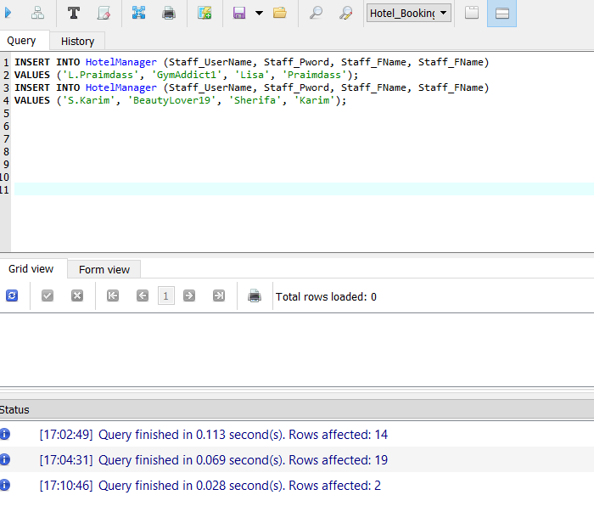
Figure 26: Insert data in Hotel Manager statement.

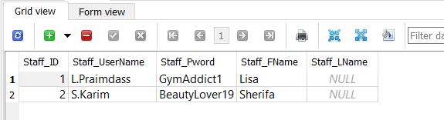

Figure 27: Inserted data in Hotel Manager table

Insert Data – Room Type

INSERT INTO RoomType (Room_OccupancyType, Room_View, Room_Amenities, Room_Rate)
VALUES ('Single', 'East', 'Basic, Balcony', '129.99');
INSERT INTO RoomType (Room_OccupancyType, Room_View, Room_Amenities, Room_Rate)
VALUES ('Single', 'East', 'Basic, No Balcony', '99.99');

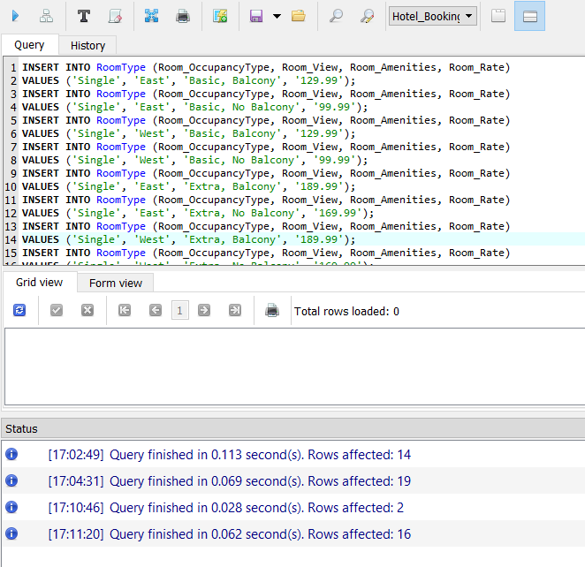
Figure 28: Insert Data into Room Type statement

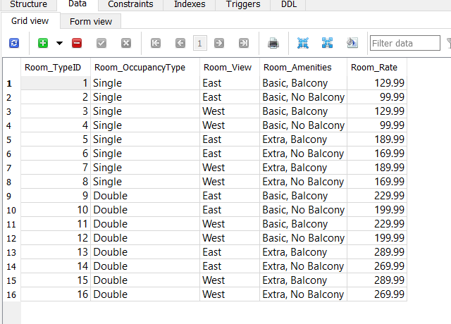
Figure 29: Inserted Data in Room Type table

Insert Data – Room Num

INSERT INTO RoomNumber (Room_NumID, Room_TypeID, Room_Num, Floor_Num)
VALUES ('SE02', '2', '02', '1');
INSERT INTO RoomNumber (Room_NumID, Room_TypeID, Room_Num, Floor_Num)
VALUES ('SW04', '4', '04', '1');

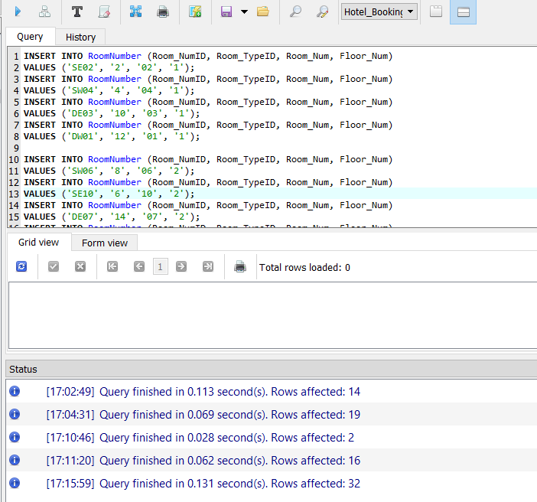
Figure 30: Insert Data in Room Num statement

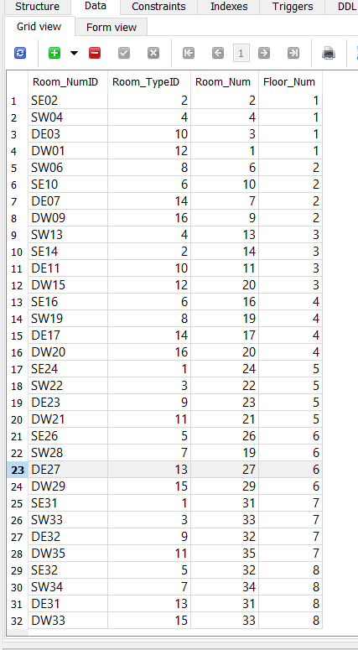
Figure 31: Insert Data in Room Num Table
Insert Data - Booking

INSERT INTO Booking (Customer_ID, Check_InDate, Check_OutDate, Room_Type, Floor_Num, Room_Amenities, Num_OfGuests, Special_Requests, Booking_Status)
VALUES ('1','24/06/2021','31/06/2021','Double', '6', 'Extra and Balcony', '2', 'Birthday Cake and Wine', 'Pending' );
INSERT INTO Booking (Customer_ID, Check_InDate, Check_OutDate, Room_Type, Floor_Num, Room_Amenities, Num_OfGuests, Special_Requests, Booking_Status)
VALUES ('2','24/06/2021','31/06/2021','Double', '6', 'Extra and No Balcony', '2', 'Baby Cot', 'Pending' );

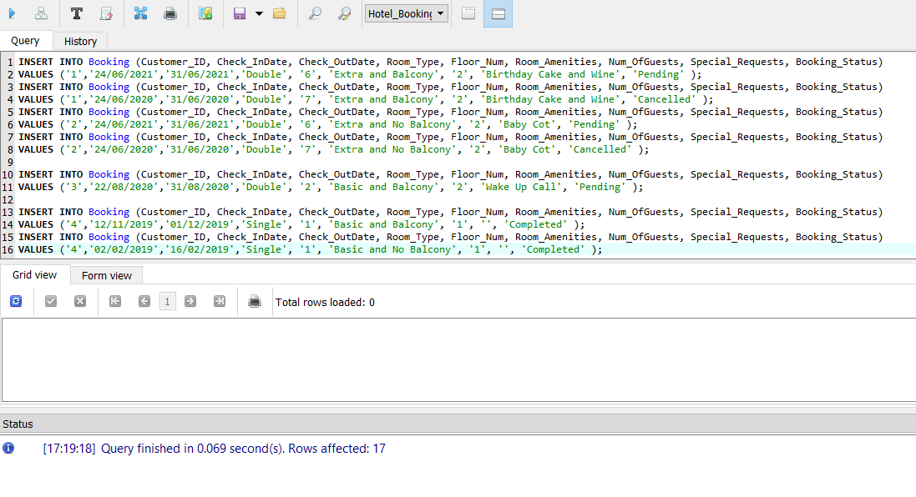
Figure 32: Inserted Data in Booking statement.

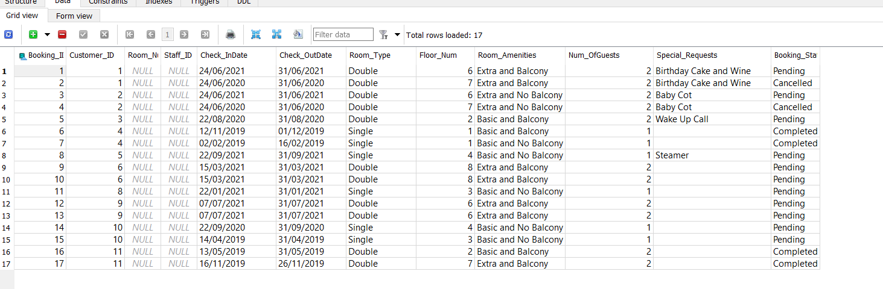
Figure 33: Inserted Data in Booking Table

Discussion and Reflection

In preparation to complete this assignment the case study was reviewed and analysed. Assumptions were made based on this and on research in other hotel systems and features.

Five entities were identified Customer, Booking, Staff, Room Type, Room Number and Credit Card. Staff and System Administrator could be possible other entities but was not included at this time.

The attributes included in Customer were based on the case study with an additional option for Date of Birth. Gender and Age were also possible options for inclusion and could be included in the future. Credit Card was shown separately based on the assumption multiple cards can be added as Customers may possess more than one card. A future option for the Credit Card will be the billing address if it differs from the Customer’s home which was something I remembered after the query design.

Room Type and Room Number were created separately on assumption of the hotel may have many rooms and varies types of rooms. It seemed better to manage the data this way to avoid cumbersome tables. The database leaves room for addition room types and room numbers to be included in the event of expansion to create more rooms or the refurbishment and introduction of room types such suites etc.

An assumption is made that the could be two Hotel Managers assigned to the Day and Night shift. That they would assign Bookings quickly to avoid customer dissatisfaction and they would use the system as regularly as that of the front staff.

As the amenities weren’t mentioned the table and data was designed to differentiate rooms and amenities categories of basic and extra were assumed and rooms with and without balconies ere entered. Assumed rates based on these variations were entered for testing of queries which I was not able to complete.

Booking table was designed using the listed attributes with the assumption guests may have a preferred floor, that some may book a double room for only one guest and they make have special requests that may be able to be accommodated.

Creating the ERD with this data was at first a bit challenging Visual Paradigm was tricky to navigate and drawing via draw.io was tricky and took a few tries to make it neat. This assignment however helped me further understanding diagrams and their relationships. The notation was also something I need to think out and write down to understand.

The ERD was used to create the Normalization form which I found to be very challenging and took some research and review to understand. This task and had to make several revised tables before inserting the completed table on this report. The assumption is that one customer can have one or more bookings and therefore the booking can be shown as a separate table under 1NF this also applies for the Credit Card table. The rules for 1NF was not too difficult to grasp but the 2NF table was a bit trickier and based on the single attribute primary key in 1NF there were not partially depend keys in 2NF and thus it remained the same in both forms. The 3NF was easier to identify and understand due way this is linked back to the ERD which allowed less seconding guess. This particular task will be one I will have to practise a lot to further grasp as it was the most challenging aspect of this assignment.

The Physical Table and Data Dictionary task was not as difficult as the previous semester included a database with one of the final assignments. The Skeleton Tables were created based the ERD with the Primary and Foreign Keys clearly identified.
The Data dictionary was prepared with the idea that SQLite is used to implement the database, as I was more familiar with this versus myPHPadmin. I preferred to use it for the assignment and possibly try this later with it at some point. I made a few revisions to this table while implementing the database from inclusion of more attributes to changing the Datatype when I realised it was not the appropriate choice.

The Create Statements for the Entity Tables were also familiar, while creating these tables I made changes to the datatypes. To avoid corrupting my report I tracked these changes via a separate sheet, copying all statements made to this and noting the changes made. The Insert Statements took longer to implement and took more thinking this created more trial and error due to the queries I hoped to perform after.

The query designs were thought with the idea of the system functionality in terms. I thought of how will the status be updated by the manager and assigned after the record was made by the booking and thus why I tried the update query. If there are users registered by have not booked a room, would management want to create a promotion to reward frequent users and attach registered users?

The Left Join Query allows this information to be pulled. What if the hotel needs to update their records to ensure payment details are correct, you can view the pending customers against their booking dates to flag to request updated information? An Inner Join with three tables can be used, this can be used also to check varies other tables such as Customer, Booking and Room Type or Booking, Room Number and Room Type to see which can be assigned.

Another function would probably to make sure the Booking Status is accurate for room assignment and payment tracking. The forth query ran to show the completed this would have served better had I created information to reflected if it was paid. This will be an attribute to remember for future inclusion. Sometimes Customers may register twice such as if they don’t have access to their old account, this can be differentiated via a distinct query.

Throughout the preparation and implementation of this I ran into various errors which required research and trial and error to fix. I tracked the changes and errors but did not take screenshots which I would have liked to include and how I fixed those. However, the process of keeping all the statements in a separate document meant no spending too much time typing over and over and forgetting what was previously done which almost became easy to do. After all tables were created, data inserted and queries ran I then prepared the report and snippets for inclusion which this time ran with no errors.

This assignment was challenging and helped me grow as a student. I really appreciated the fact it touched on all steps and helped me identify my weaker areas. The trial and error stage helped me come up with a process I would use and improve upon moving forward. I also gained appreciation for the various applications used, SQLite has its pros and cons vs myphpadmin but learning aspects of both is highly beneficial as well as learning their various datatypes and syntax.

